About the course
Computers and the Internet are integral aspects of modern life. We are surrounded by, and often reliant on, devices that have computing power at their core. From governments and multi-national businesses to local enterprises and individuals, we rely on computer networks and software to keep the global economy running. Studying computing will enable students to develop a range of knowledge and skills necessary for success in the modern world.
This course combines key concepts related to computational thinking, information technology and digital literacy to provide students with skills and knowledge across the main elements of computer science. At its core, is computational thinking, the problem solving, and logical thinking skills used by computer scientists and programmers to solve complex problems, which can also be applied to real world issues in many other subjects and disciplines. Writing programs allows students to put these skills to the test, and to develop their ability to work through problems and find solutions.
Whilst not everyone will pursue a career as a programmer, most people will use a variety of software applications in their everyday lives. Learning how to use software correctly and adeptly to produce effective presentations, documents or spreadsheets to convey information is an important skill for many careers. Alongside this comes the ability to develop and edit audio and visual media.
Understanding the development of computing, how computers and the Internet work, how to evaluate digital content and the ethical issues surrounding the use of computers help us to put the technology into context. Whatever technology we use, it is important they we know how to use it safely and respectfully so that we can make the most of opportunities in our future lives.

Prior knowledge
Before starting this course, pupils should have studied the national curriculum at Key Stage 2 and have some experience of the National Curriculum content for Key Stage 2 including:
- designing, writing and debugging programs for a specific purpose
- decomposing problems to make them more manageable
- using variables, input and output
- the concept of sequence, selection and iteration
- using logical reasoning to explain how simple algorithms work and to detect errors in them
- computer networks and the internet and the service they provide
- searching the internet effectively
- collecting, analysing, evaluating and presenting data for a specific purpose
- using a range of software and resources to create content for a specific purpose
- using technology safely and responsibly.
Each of the elements above will be revisited to ensure all pupils have access to the learning throughout the course.
The baseline test provided with this course can be used to identify starting points and any key issues that need to be addressed before commencing specific topics.

The approach
Progress in Computing is structured into units. While it is recommended that they are studied in the order presented in the student book, it is possible to use a different order if preferred. The only exception is the Python programming units, where concepts and skills rely on prior learning.
Where appropriate, the course uses the PRIMM (Predict, Run, Investigate, Modify, Make) approach to improve the pupils understanding of the material. While this approach is largely associated with coding, it can be used effectively in many of the modules. Similarly, the pair programming approach, which involves students working together to solve problems, largely associated with coding, can be applied more generally. Students with similar skill sets working in pairs can reduce the cognitive load and increase their confidence. It may be appropriate in some cases to provide partial answers taken from the teacher notes to help students grasp the concepts and enable them to move on to the next stage. The course is also aligned with the 12 key principles of the National Centre for Computing Education's pedagogical approach.
The content of the course covers the requirements of the National Curriculum at Key Stage 3. An overview of how the units link to these requirements can be found in the National Curriculum cross reference table. In addition, details of how lessons and activities are mapped to the National Curriculum are referenced in individual lesson plans.
Not all students will progress at the same rate and it is likely some pupils will not complete all tasks, and also likely some pupils will complete the tasks and wish to extend their knowledge and skills beyond those in this course. Where it is appropriate, advice is included in the individual lesson plans about stretch and support activities or alternative approaches that might be considered.
For pupils with English as a second language or who have difficulty following lengthy text descriptions, where possible, we have included printed copies of on-screen instructions and a number of video presentations that should aid understanding.
The course contains many digital elements that are available via the Boost platform and additional materials from other sources can easily be incorporated into the lessons if using the Boost system. Where appropriate, details of additional digital resources to support the learning, can be found in the individual lesson plans.
The course introduces students to a variety of software applications. As well as providing a sound basis for further exploration of the subject, students will be able to make effective use of the software in other curriculum areas.

Learning objectives
Progress in Computing is designed around five core learning objectives.
By the end of the course, students should be able to:
- Know and understand the key concepts and principles of computing
- Apply knowledge and understanding of the key concepts and principles of computing
- Analyse problems in computational terms
- Plan creative solutions to problems
- Develop confident and responsible use of modern information technologies.
These have been developed to ensure progress from the end of Key Stage 2 through the entirety of the Key Stage 3 National Curriculum, in addition to developing students’ digital literacy skills and preparing them for the range of computing options on offer at Key Stage 4.

Progression pathway
The learning objectives provide the framework for the Progress in Computing progression pathway. The pathway assumes students have a grounding in computing from Key Stage 2 and prepares them for one of the many Key Stage 4 options on offer, including GCSEs, Cambridge Nationals and BTECs. Three-year and two-year progression pathways are available as separate documents, both of which map the course to the Key Stage 3 National Curriculum.
The structure of each module is also based on the core learning objectives, with all content and activities supporting the development of the relevant knowledge and skills, and all assessment opportunities enabling you to track and measure progress throughout the course. Module-level detail is provided on the relevant ‘About the module’ documents.
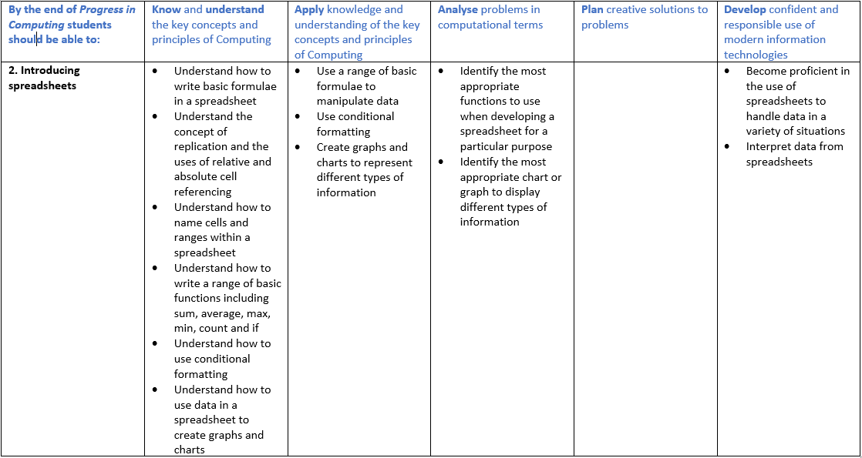
- An example of the progression pathway from the Introducing spreadsheets module

Key concepts
The progression pathway has also been distilled into eight key concepts and all resources in the course have been tagged to these concepts to help you search for and find what you want more easily. The concepts are as follows:
- Algorithms
- Programming
- Application software
- Digital media
- Computers
- Communication and the Internet
- Data
- Safety and ethics.

Assessment opportunities
The course includes a baseline assessment comprised of 36 questions that cover basic concepts from all of the modules included in Progress in Computing. It is intended to give an indication of students' prior knowledge and act as a benchmark against which progress can be measured.
Formative assessment is built into the lessons, through teacher observation of activities and questioning detailed in the lesson plans. This helps to ensure that misconceptions are recognised and can be addressed if they occur. Common misconceptions are highlighted in the lesson plans.
Each module includes short auto-marked quizzes to check knowledge at the end of most lessons. There is also a summative assessment at the end of each module, which draws together the knowledge and skills developed in the previous lessons. Finally, the Projects module consists of three six-week projects and we recommend you choose two for your students to complete as their end-of-KS3 assessment.
The projects you choose may depend on the KS3 learning you want to assess and/or the options students have at KS4.
Project 1 is about programming and points the way to GCSE and iGCSE Computer Science.
Project 2 is about spreadsheets and points the way to Cambridge Nationals Information Technologies and the BTEC Tech Award in Digital Information Technology.
Project 3 is about video and sound editing and designing websites and points towards Cambridge Nationals Creative iMedia.

Structure
Each module consists of the following:
- About the module: this summarises the content of the module, lists the learning objectives from the progression pathway, outlines the assessment opportunities contained within the module and explains the prior learning that is required for students to get the most out of the module.
- Lesson plans: each module consists of six lessons and each lesson or double lesson has an accompanying lesson plan. These lesson plans are your starting point, because they show you how the other resources can be used to deliver the lessons and they contain answers for you to refer to.
- Presentations: each lesson or double lesson has an accompanying presentation. These support you in teaching the lesson outlined in the lesson plan, containing theory and pointing to or describing activities.
- Associated resources: each module is accompanied by a wide range of associated resources, including videos, animations, spreadsheets, worksheets and quizzes. The lesson plans suggest when to deploy these to greatest effect. Where there is more than one worksheet or spreadsheet for a lesson, these are provided in a single file and individually, so that you have flexibility over how you use them. Where appropriate, we have also provided Excel versions and Google Sheets versions, as well as PowerPoint and Google Slides versions of resources.
The activities in each lesson are numbered consecutively. So, for example, the first activity in the first lesson of all modules is called Activity 1.1. If this is accompanied by a worksheet, the worksheet will be called 'Worksheet 1.1', and, if it is accompanied by an interactive activity, the interactive activity will be called 'Interactive 1.1'. Some activities are described in the presentations only and are not accompanied by associated resources.

The Student Book contains a distillation of the key content covered in the lesson plans, lesson presentations, videos and activities. Every double-page spread in the Student Book covers a lesson’s worth of content.
It is available in digital and print formats and is designed to be used:
- as a reference if you prefer to teach with a textbook
- to facilitate unplugged activities
- for independent student work, including recap and review or extension and remediation
- in remote-learning situations where access to the internet or technology is limited
- as a teaching tool in cover lessons or for non-specialist teachers.
The Student Book contains a selection of each lesson’s main activities, often in a condensed and slightly adapted format. The resources needed to facilitate those activities are included as discrete resources on Boost and, if you are using the teaching and learning resources to deliver your lessons, the approach taken by the Boost resources (as described in the lesson plans) should supersede the approach taken in the Student Book.

